**Created by Ken Ngai**



Photo Book Maker

**requirements document**

**Table of Contents**

2. Revision History 3

3. Introduction 4

4. Intended Audience 4

4.1 BCIT Staff and Student 4

5. Features and Functional Requirements 5

5.1 Login Process 5

5.2 Main App Page 5

5.2.1 Template Menu 5

5.2.2 Toolbar Menu 5

5.2.2.1 Image Manager Menu 5

5.2.2.2 Layout Menu 5

5.2.2.3 Background Menu 6

5.2.2.4 Text Menu 6

5.2.2.5 Sticker Menu 6

5.2.2.6 Filter Menu 6

5.3 Canvas 6

5.3.1 Upload Picture 7

5.3.2 Drag and move element 7

5.3.3 Page Slider 7

5.3.4 View 2 pages at a time 7

5.4 Download 7

5.5 Order 7

6 Non-Functional Requirements 8

7 Example Tutorials 9

7.1 Scenario 1: Login and create a new design from template 9

7.2 Scenario 2: Adding Image to the page 10

7.3 Scenario 3: Changing layout of the page 13

7.4 Scenario 4: Adding Text to the page 13

7.5 Scenario 5: Adding Sticker to the page 15

7.6 Scenario 6: Adding Background to the page 16

7.7 Scenario 7: Applying Filter to the image 17

7.8 Scenario 8: Downloading the design as print ready pdf 17

7.7 Scenario 9: Send order request to Campus Copy & Print 18

# 2. Revision History

|  |  |  |  |
| --- | --- | --- | --- |
| **Version** | **Status** | **Publish/Revision Date** | **Authors** |
| 1.0 | Created | March 20, 2018 | Ken Ngai |

# 3. Introduction

BCIT Link Magazine Photo Book Maker is a single-page visual design web application that will allow BCIT students to create customized books using their own content from BCIT Link Magazine web application. Then It will generate a downloadable print-ready pdf or ordering confirmation that sends to the Campus Print & Copy allowing students to print at a reasonable price, and made ready for pick up by students on campus.

# 4. Intended Audience

## **4.1 BCIT Staff and Student**

The main audiences for this web application (app) are individuals who are BCIT staff and student that can access their BCIT account. The user would need to have a laptop or a desktop device to be able to access the web application. For user with mobile device, they will not able to control the app, since this is a desktop web application. A possible solution beyond the scope of this project would be to introduce a native app for mobile or a progressive web app for any device using browser. Hence, this app will be designed for individuals who want to create customized print object within our template to generate a print-ready pdf to print at low print on campus.

# 5. Features and Functional Requirements

## **5.1 Login Process**

A user is shown log in options using BCIT ID. The Login Screen will ask for the user’s BCIT ID as well as a password for the account. (Require asking BCIT web developer to access their login system to check if the user is BCIT student or staff.)

## **5.2 Main App Page**

Once signed in, user will be able to access to the core feature of the application.

## **5.2.1 Template Menu**

Once signed in, it will go directly and open the Template Menu. The Template Menu is for choosing a template that the user wants to start customizing, such as photo book and photo calendar. This will initialize the setting for the canvas and the layout setting, because each template will have different layout style. This area will contain information for the template and will be scalable for new template added in the future.

## **5.2.2 Toolbar Menu**

The Toolbar Menu is a toolbar for a list of tools to manipulate the pages of the design, such as

* Image Manager Menu
* Layout Menu
* Background Menu
* Text Menu
* Sticker Menu
* Filter Menu

## **5.2.2.1 Image Manager Menu**

The Image Manager Menu allows the user to upload their own images and show as thumbnail ready for drag and drop onto the page. To navigate to the Image Manager, click Image Icon in Toolbar Menu on the left of the canvas.

## **5.2.2.2 Layout Menu**

The Layout Menu contains a set of predefined layouts for user to select and apply the layout to the current selected page. It will change the number of the photo placeholder that the page contains and the arrangement of the photo placeholder.

## **5.2.2.3 Background Menu**

The Background Menu will simply contain a list of colors that the user can pick to be the background of the page. By selecting any color within the list, the background color of the page in the canvas will immediately change to the selected color.

## **5.2.2.4 Text Menu**

The Text Menu will contain a button to add an empty text box to the current page in the canvas with the current setting of the font, weight, size and color applied to it. The menu also has a dropdown menu for font, weight, size and color for the user to manipulate it. Beside the color dropdown menu will have an advanced color menu that will slide out the color picker for custom color not listed on the color dropdown menu.

## **5.2.2.5 Sticker Menu**

The Sticker Menu will have a library of Link Magazine image asset, that let the user to applied to their design. By clicking at one of the image asset, it will drop that image asset on the center of the current page. By dragging and dropping, it will drop that image asset on the location of the dropped area.

## **5.2.2.6 Filter Menu**

The Filter Menu will have a list of preset filters such as Black & White and it will have an advanced filter that the user can modify each setting separately.

The setting includes:

* Brightness
* Saturation­­
* Contrast
* Gamma
* Exposure
* Shadows
* Highlights

The filter will affect the current selected image that the user wants to modify and menu will also contain a reset to default button.

## **5.3 Canvas**

This is the main interactive area that shows the overall design of the page. It also allows the user to move, resize and rotate the image within their image holder. If anything went outside their respective image holder, then it will be clipped and not show up on the design. All the stickers and text will also have the same feature as the image for moving, resizing and rotating. They will not have the same restriction as the image, they will be clipped in the page so they can’t spread across two pages.

## **5.3.1 Upload Picture**

For quick design user can click at the image placeholder’s “Drag and Drop Here” box to upload and placed into the image placeholder. The image will be resized to fit the placeholder without destroying the image ratio.

## **5.3.2 Drag and move element**

Added text, stickers and image will able to move, resize and rotate as separate layer, so they can be arranged to place on top of each other.

## **5.3.3 Page Slider**

Below the canvas, it will have a page slider to navigate through the design. By selecting one of the page, the canvas will be updated to the selected page and the other page will be the paired page.

## **5.3.4 View 2 pages at a time**

The canvas will show two page at a time except first page and last page. This is for user to view their design side by side to get a better overall picture.

## **5.4 Download**

The Download button will export the user’s work as PDF with CMYK and 300 dpi.

## **5.5 Order**

The Order button pop out a form that require information that user needs to be filled.

Information such as:

* Email
* BCIT ID
* First Name
* Last Name
* Amount of copies to be printed
* Pickup Date
* Addition Info

The PDF file will directly be inputted into the form, so the user doesn’t have to do it manually.

Then it will be emailed to Link Magazine once it submits, Link Magazine will then send back an Order Confirmation email back to the user remind them to go to the Campus Print & Copy Centre for payment.

# 6 Non-Functional Requirements

|  |  |
| --- | --- |
| **Property** | **Measure** |
| Hardware | The web app will only be compatible with desktop browser |
| Software | The app will only be compatible with Google Chrome, Firefox, Safari and Internet Explorer |
| Usage Requirements | * The app will require a connection to Wi-Fi connection to operate |
| User Interface | * The web app should have large text, icons and vibrant colors to make things easily legible and accessible * The web app should be simplistic and intuitive enough to allow for a minimal learning curve |
| Security | * ­­­­BCIT Login System |

# 7 Example Tutorials

Interactive Prototype

https://projects.invisionapp.com/share/YDGP3WX2ZTR#/screens/288206583

## **7.1 Scenario 1: Login and create a new design from template**

BCIT user will go to https://www.linkbcit.ca/ and there will be a button that lead to this web application. Then input BCIT ID and password to login to the web application. Once the user is logged in It will unlock the web application full feature. The first thing after logged in will be picking a template design from the template menu.

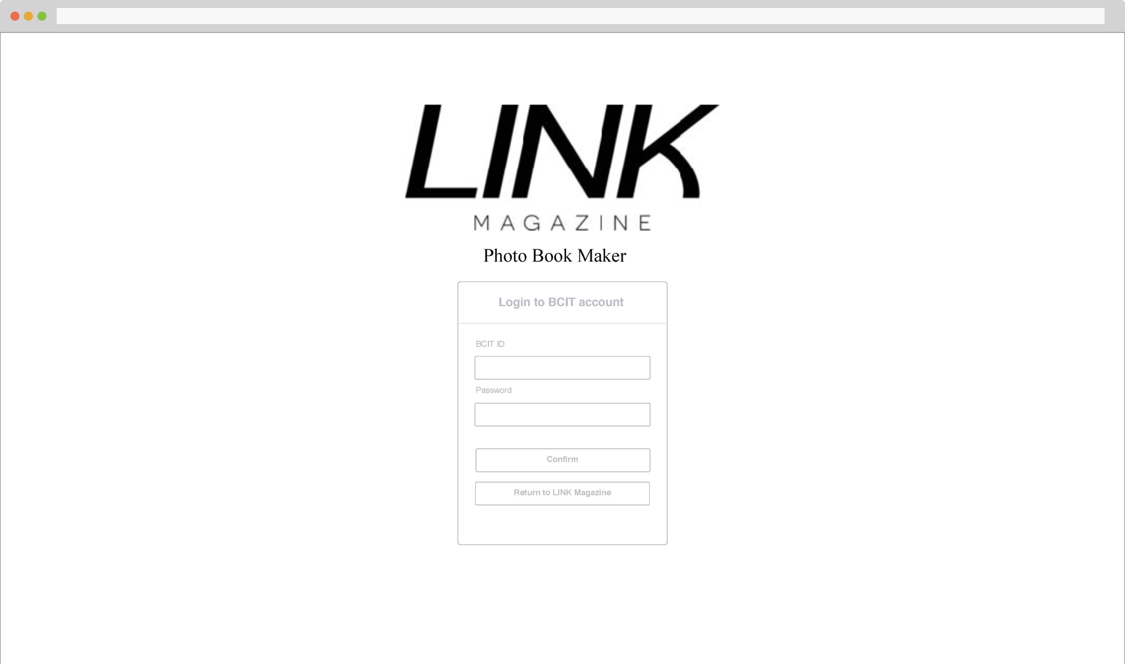

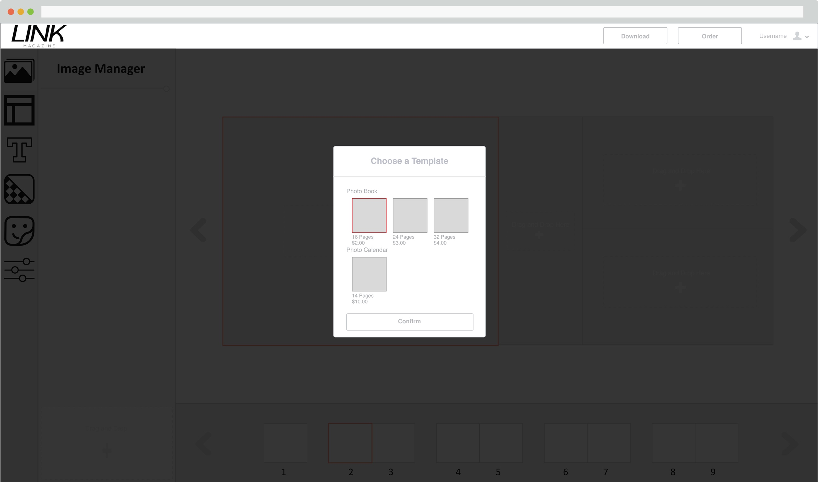

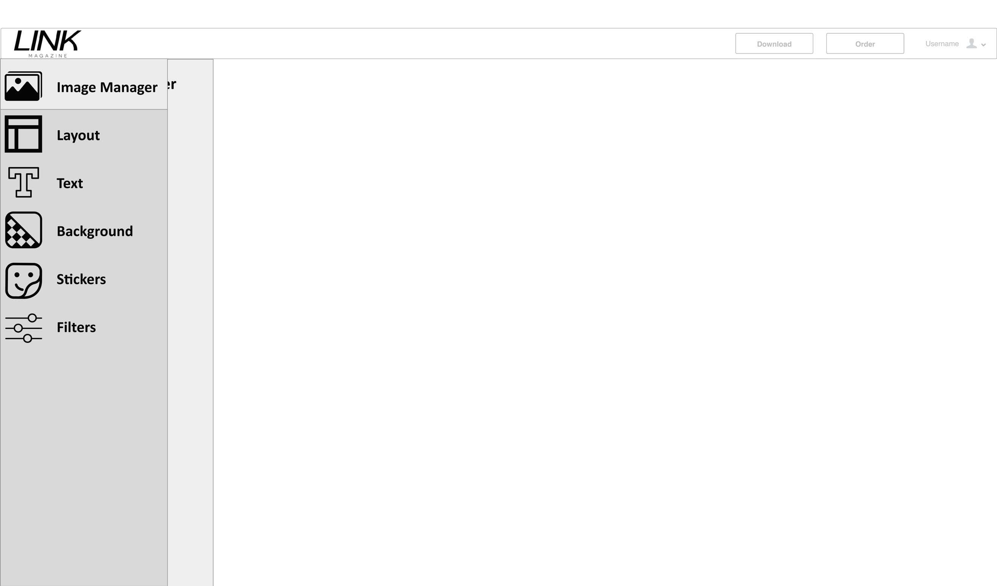

This is the Toolbar Menu on hover.

## **7.2 Scenario 2: Adding Image to the page**

To add image to page there is multiple ways. The first one is to drag and drop image from users computer to the canvas drag and drop area. The second way is to click on any of the + sign on the canvas drag and drop area, which will bring out the file explorer for the user to pick the image they want to upload and drop in the area. The third way is to first upload the image on the image manager menu with either drag and drop or the file explorer on the image manager menu drag and drop area. Then drag and drop the image from the image manager to the canvas image placeholder.

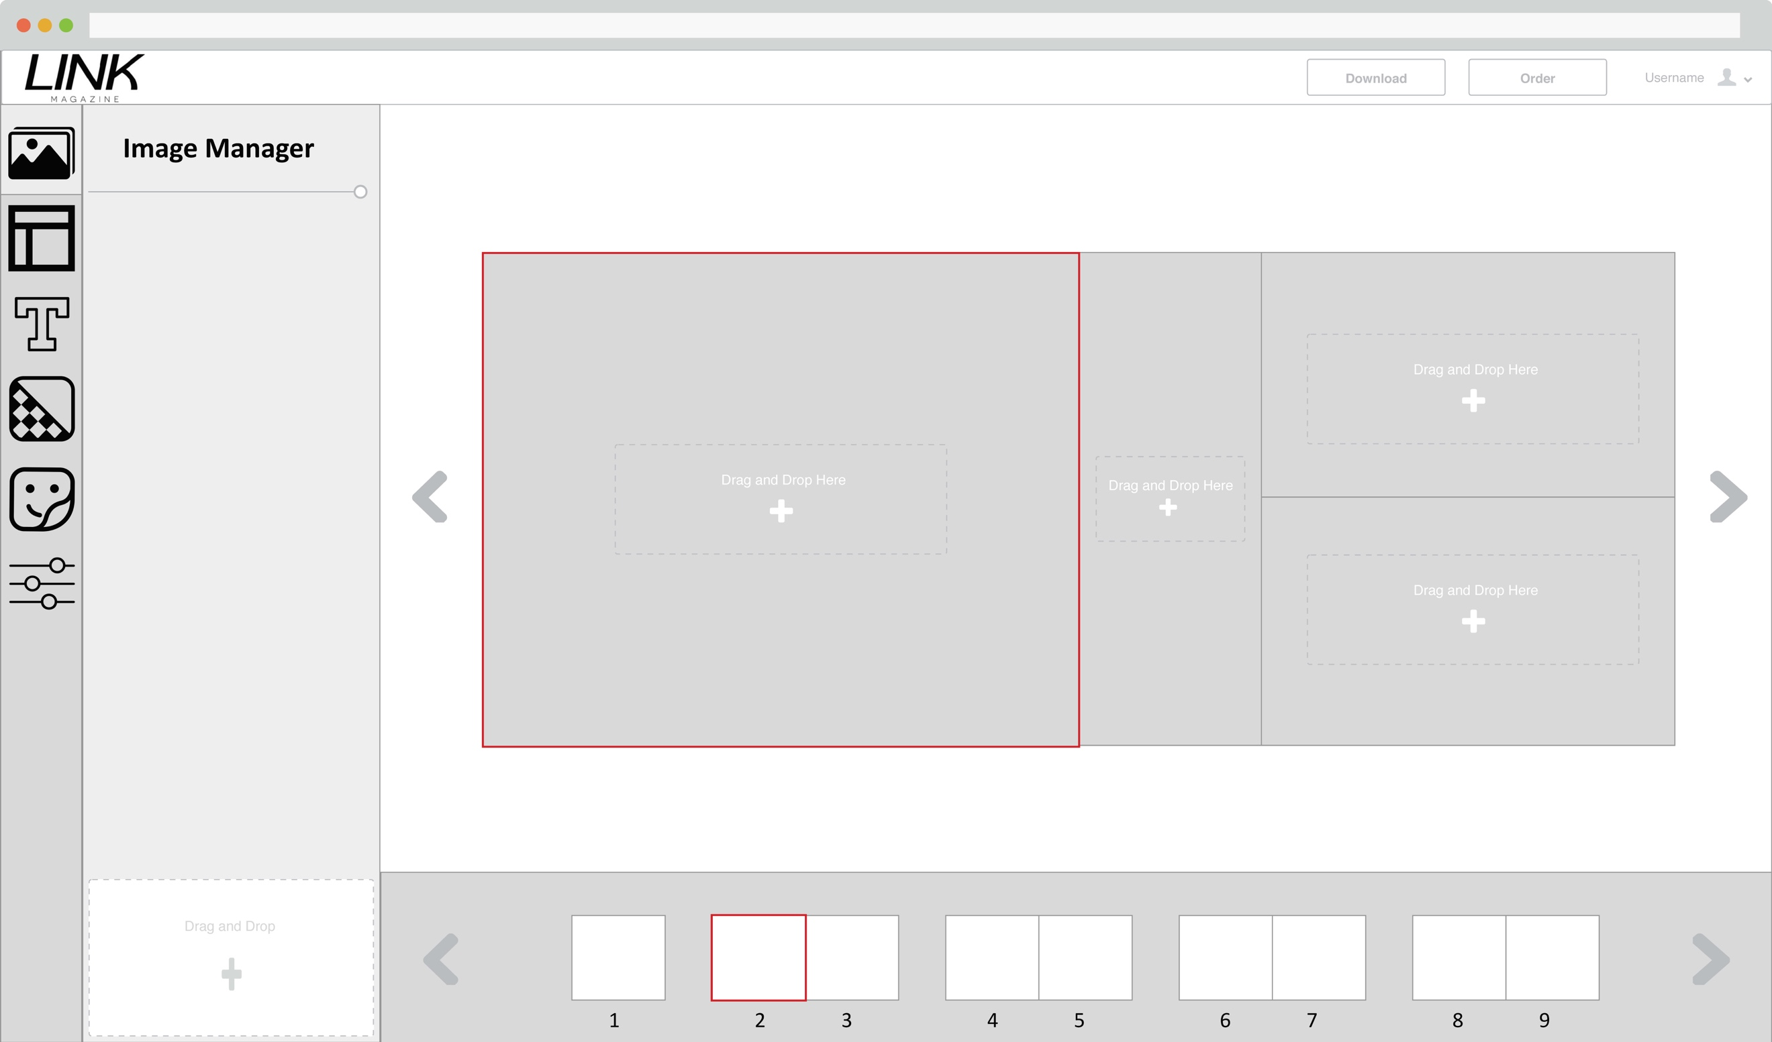

Image manager menu

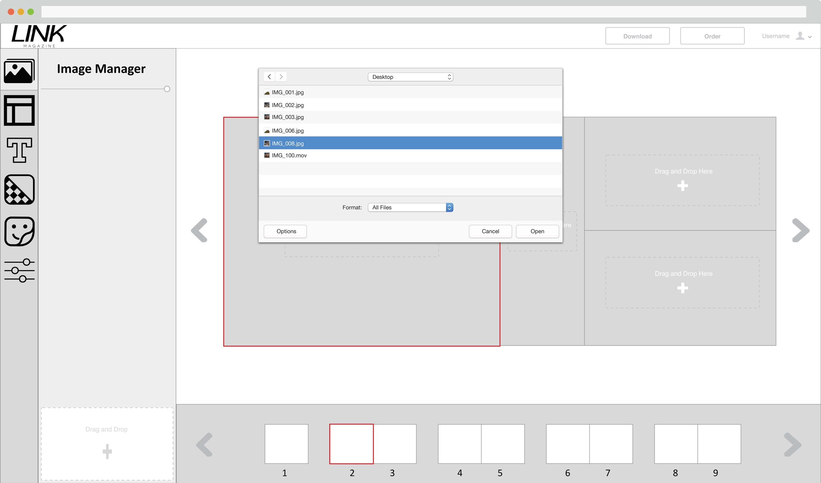

Upload image 1 using file explorer on the Image manager menu

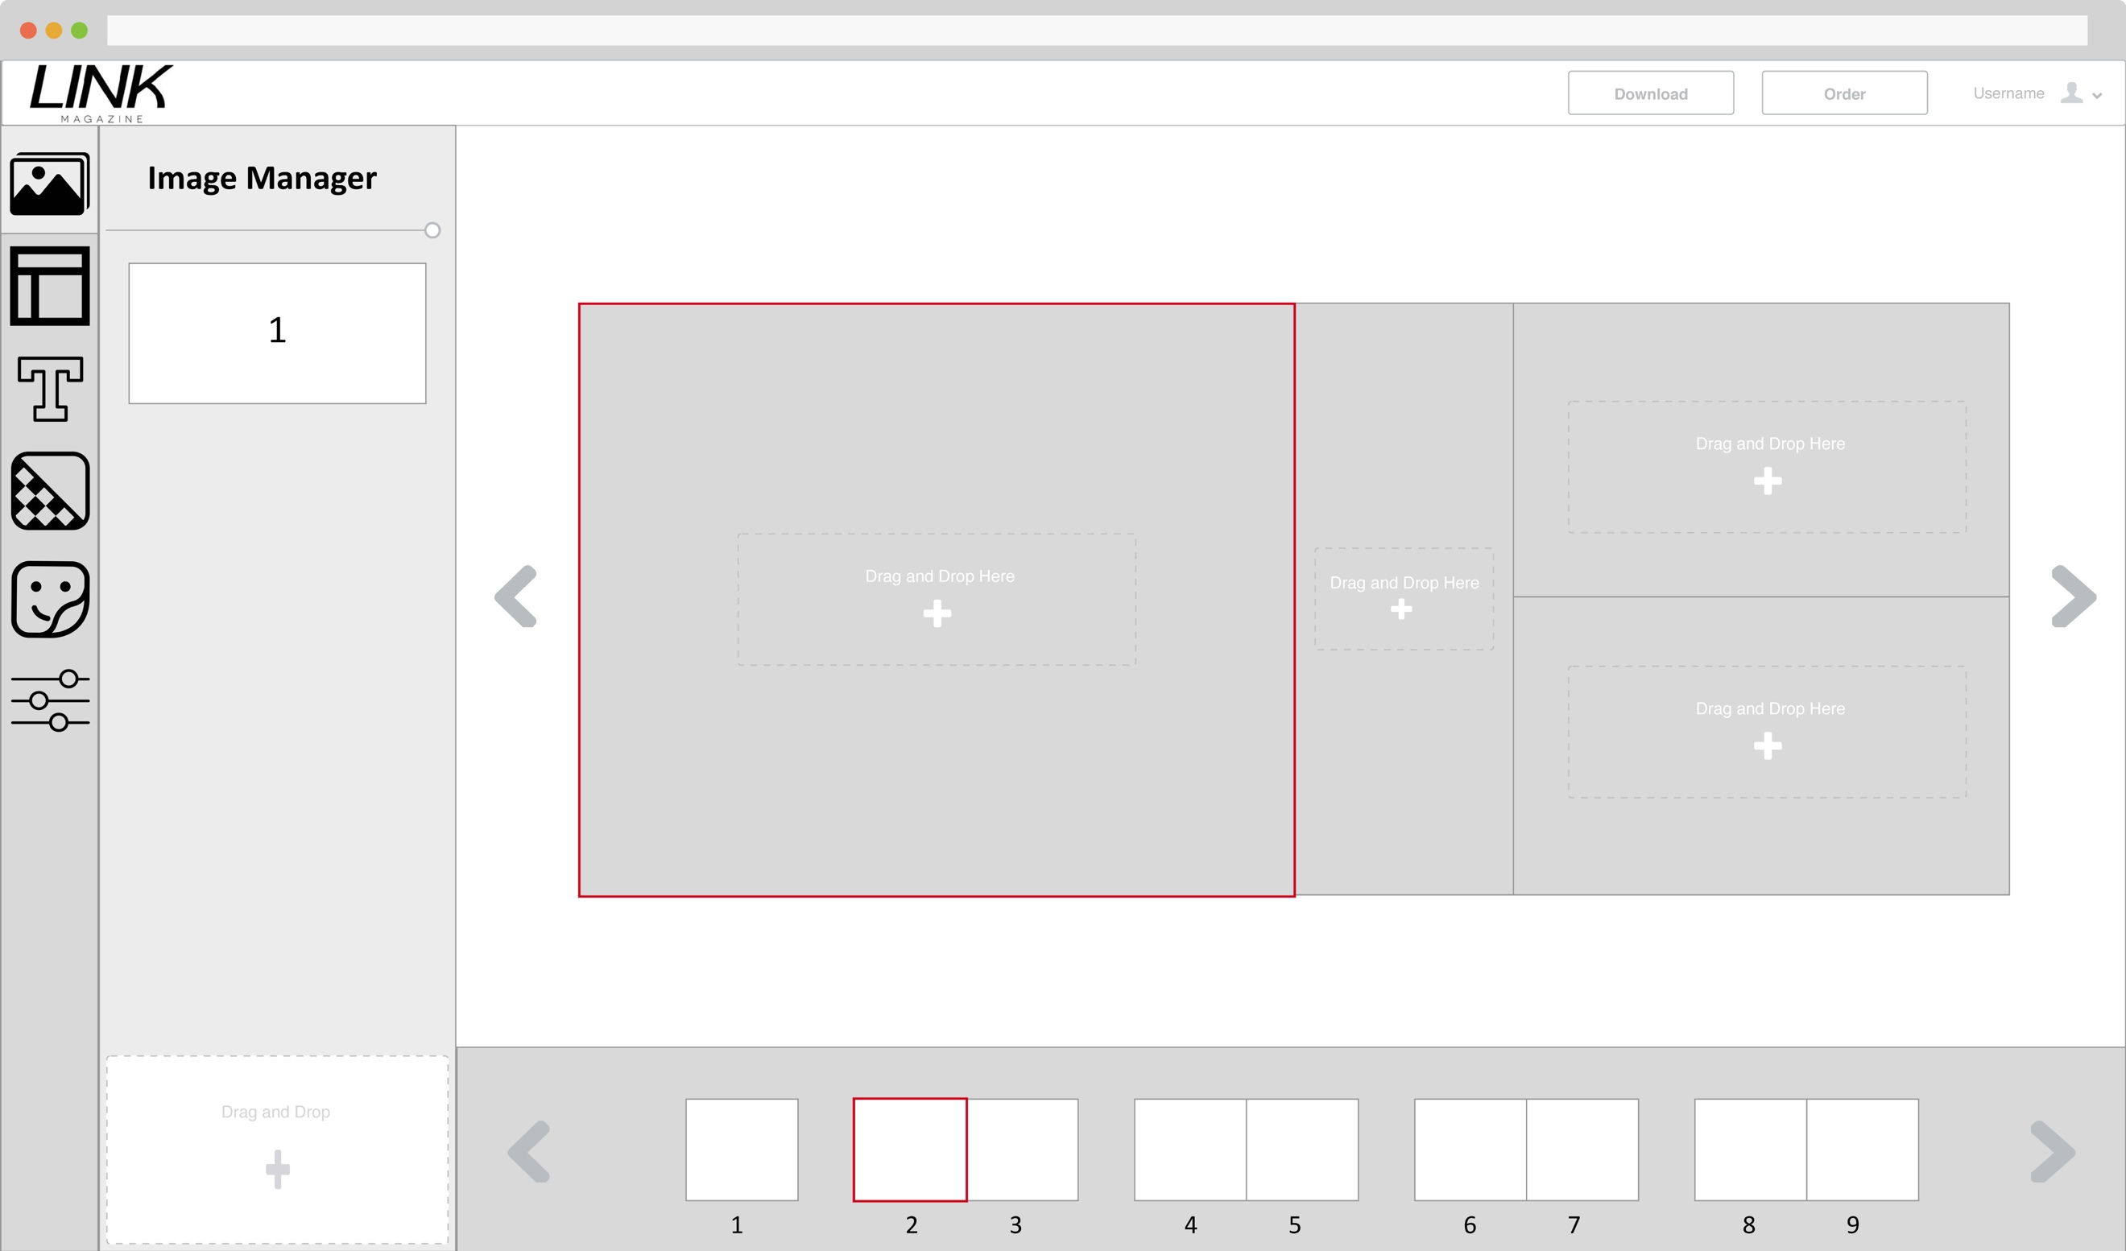

Image 1 uploaded to image manager

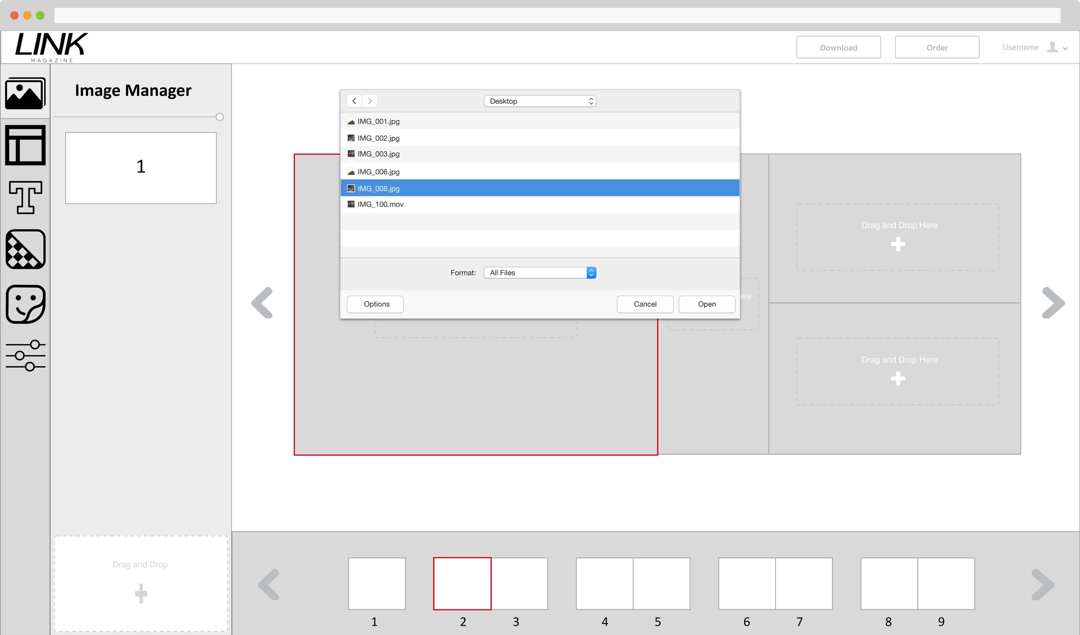

Upload image 2 using file explorer on the Image manager menu

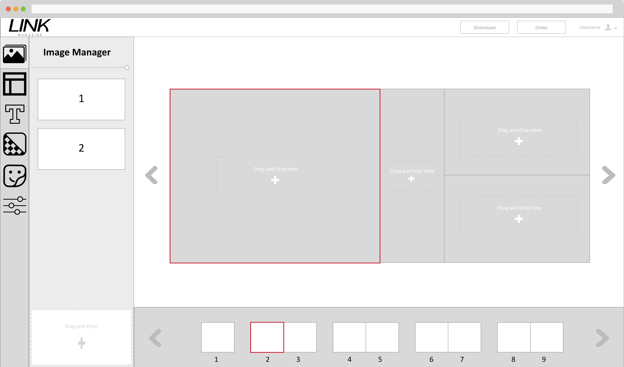

Image 2 uploaded to image manager

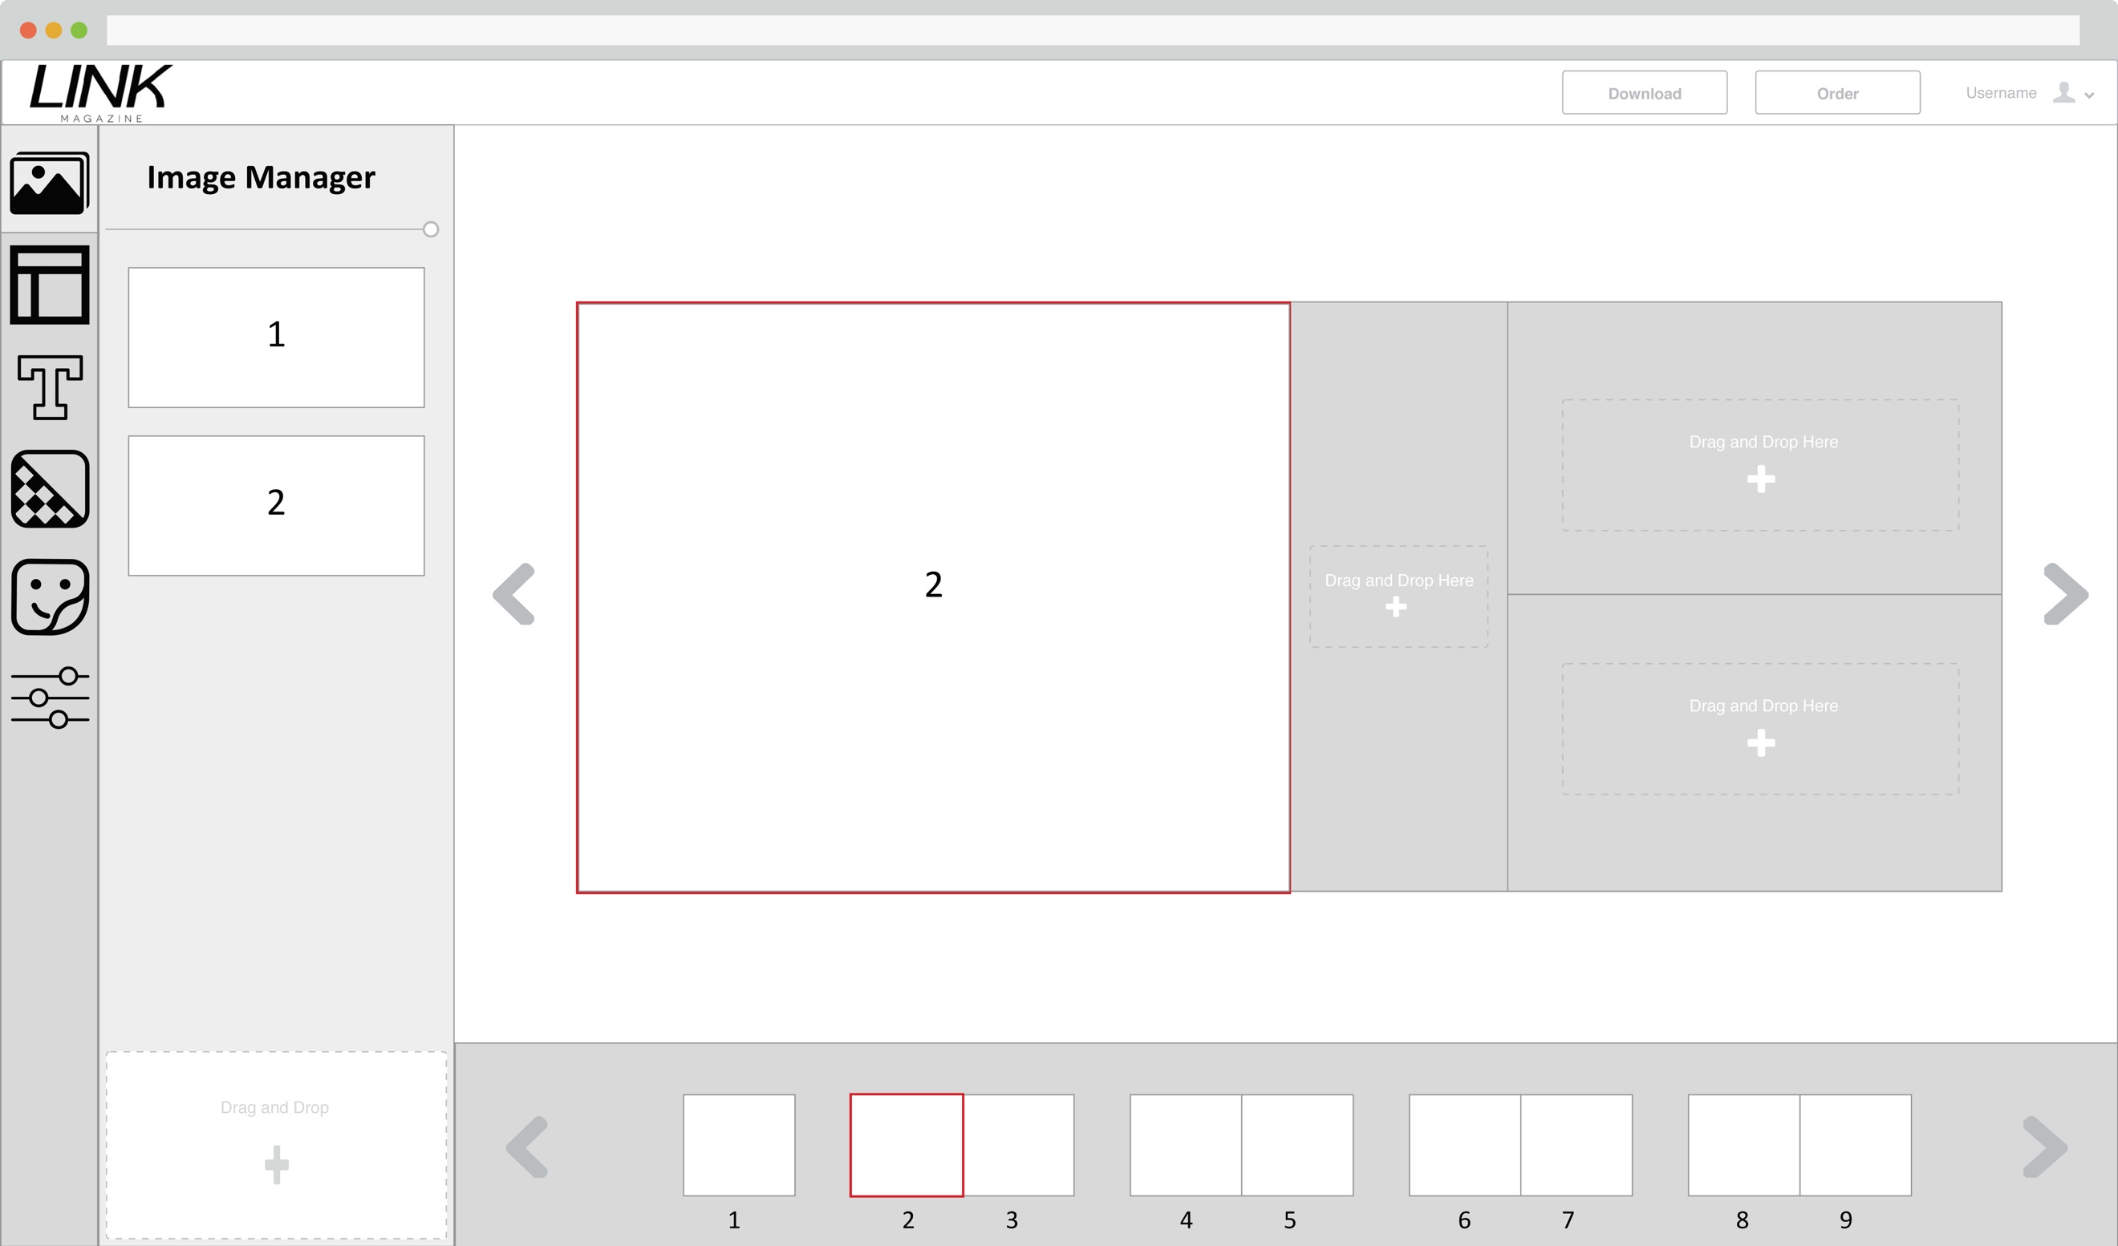

Drag and drop image 2 onto the image placeholder on page 2

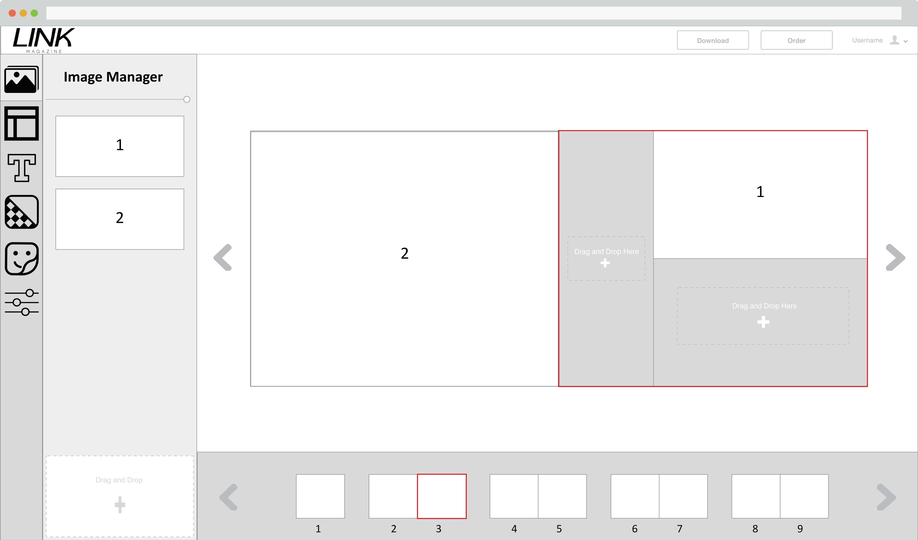

Drag and drop image 1 onto the image placeholder on page 3

## **7.3 Scenario 3: Changing layout of the page**

To change the layout of the page, first select the layout icon on the toolbar menu. Then the user select the page that require the change in layout, and select one of the many layout in layout menu to apply the changes.

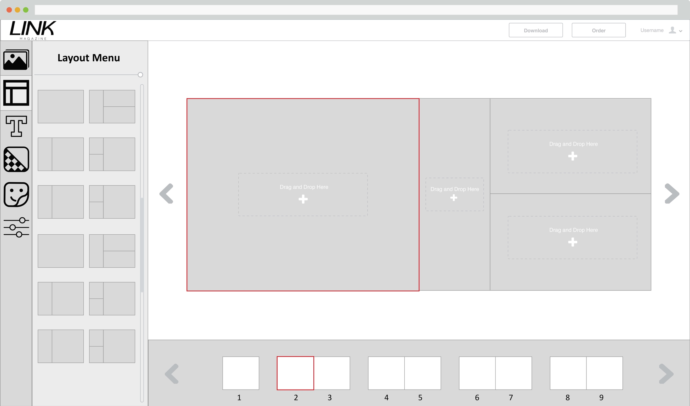

In layout menu and selected page 2 that require change in layout

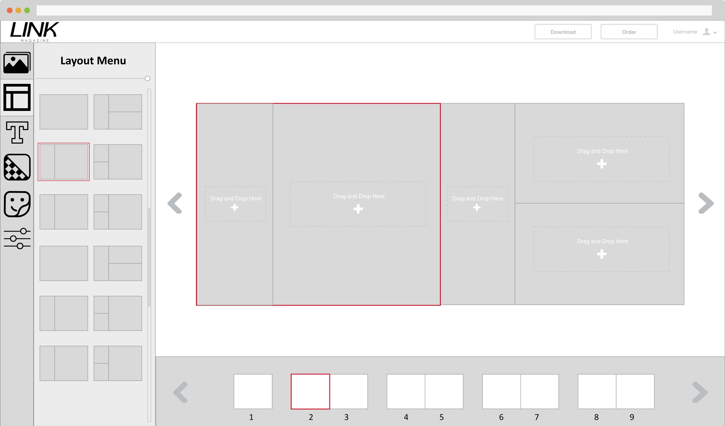

Selected a new layout for page 2 and the change has been applied.

## **7.4 Scenario 4: Adding Text to the page**

To add text to the current page, first select the text icon on the toolbar menu. Then the user select the setting for the text or leave it as default, then click on New text will add an empty text box on the current page. Then the user can click on the text box to type whatever they wanted. To modify the text after added, the user will have to select the text box that they want to change and update the new setting for the text from the text menu.

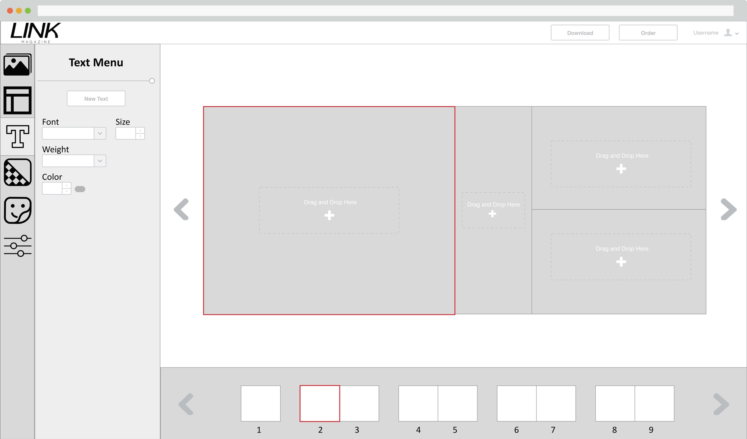

In text menu and selected page 2 that the text will be added.

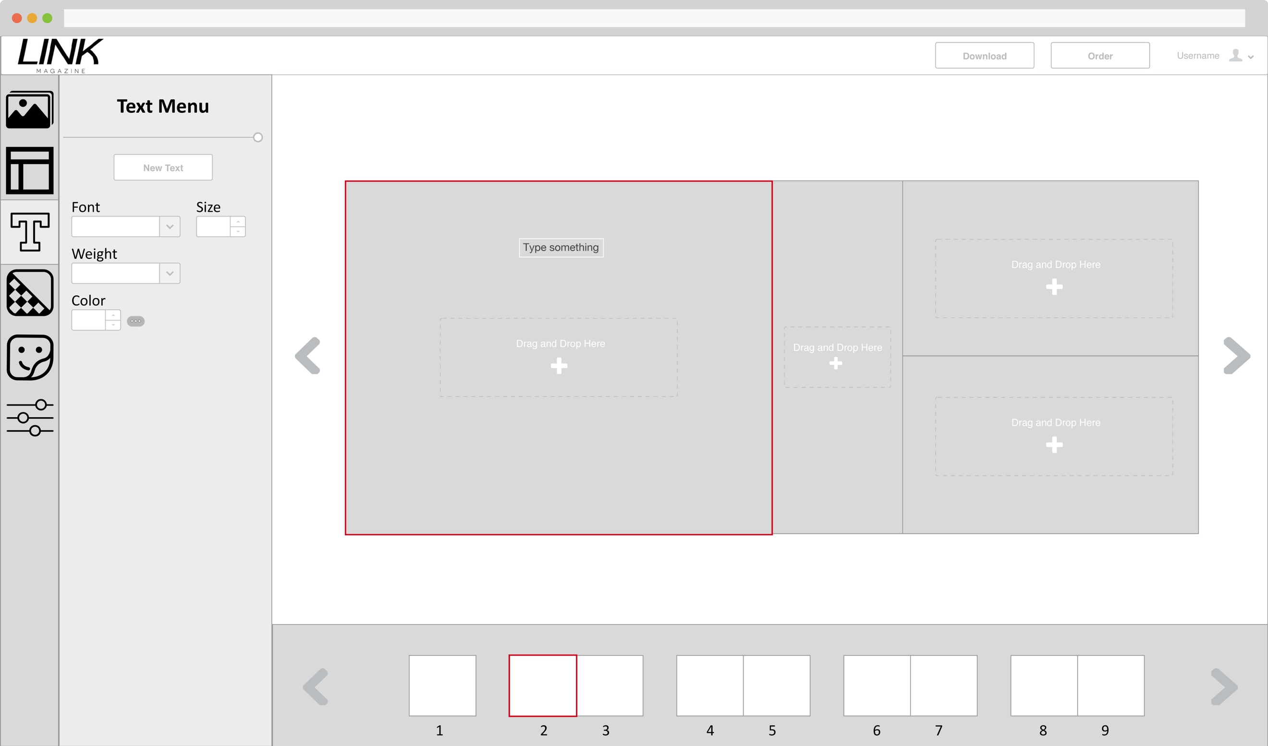

Clicked the New Text button in the Text Menu and the text box is added to page 2.

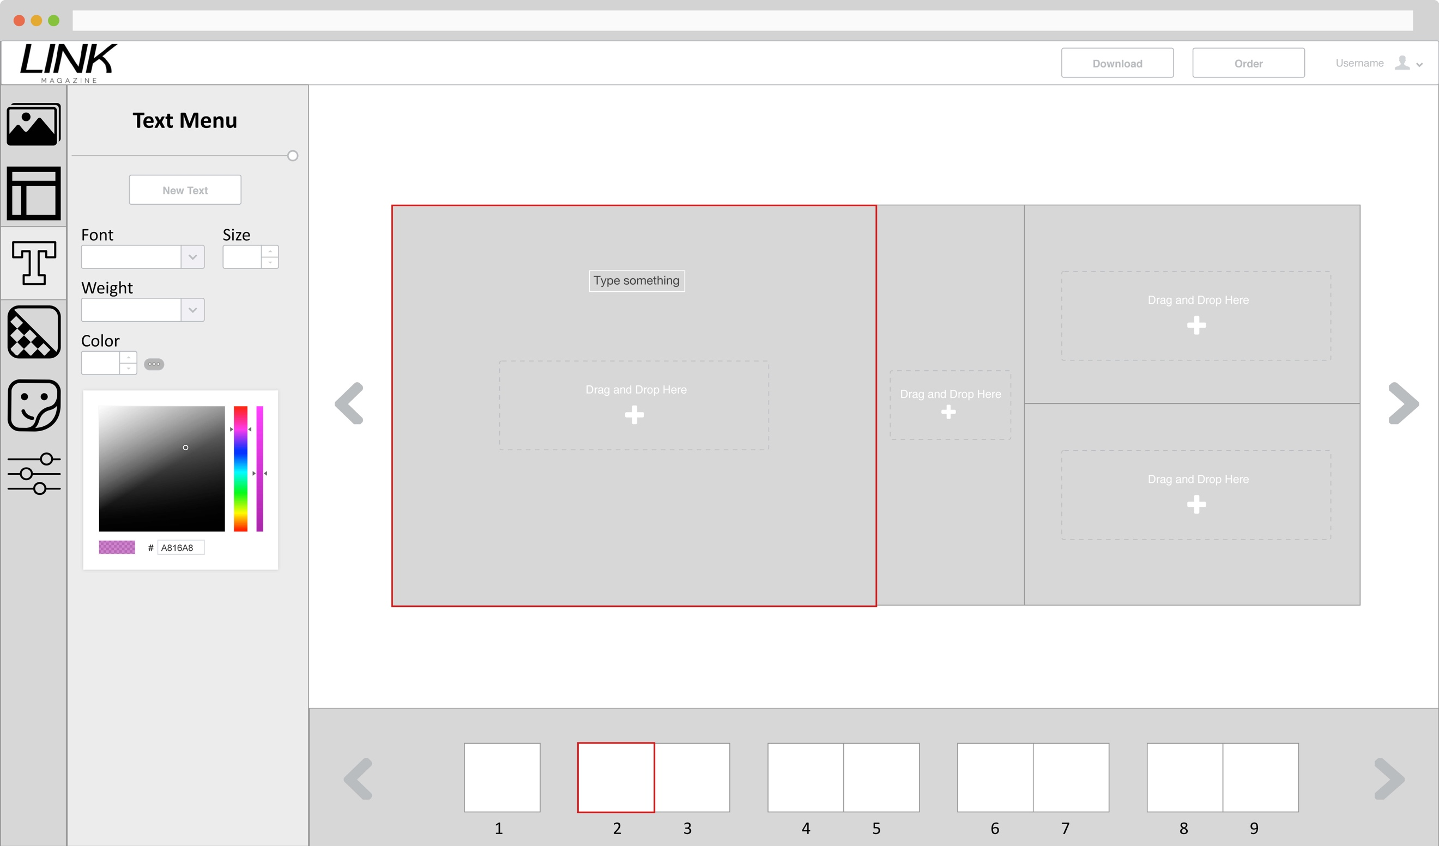

Clicked the more next to color dropdown box and a color picker slide down for custom color for the text.

## **7.5 Scenario 5: Adding Sticker to the page**

To add sticker to the current page, first select the Sticker icon on the toolbar menu. Then drag and drop the sticker on the design or click at the sticker and it will drop the sticker onto the page.

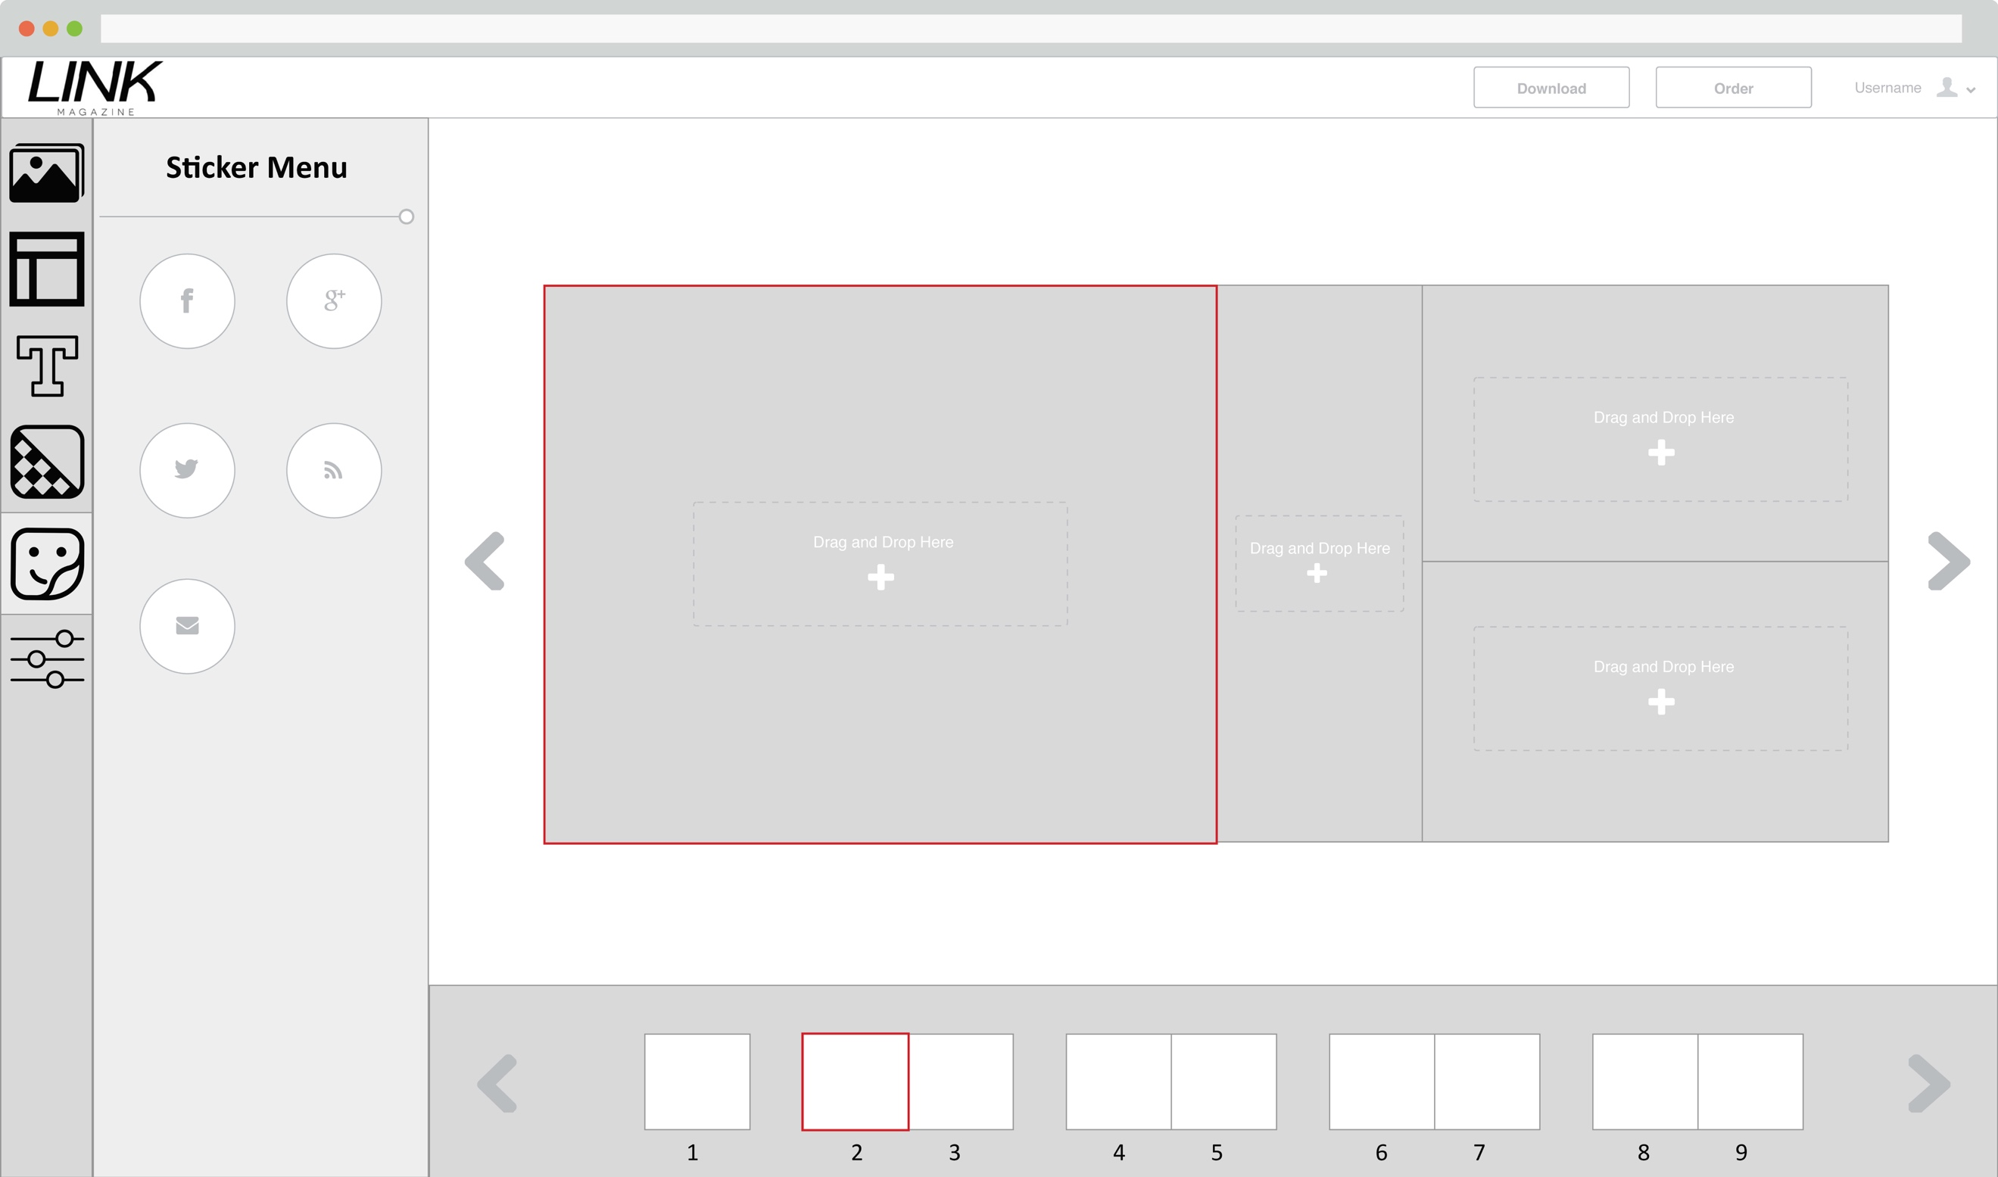

In sticker menu and selected page 2 that the sticker will be added.

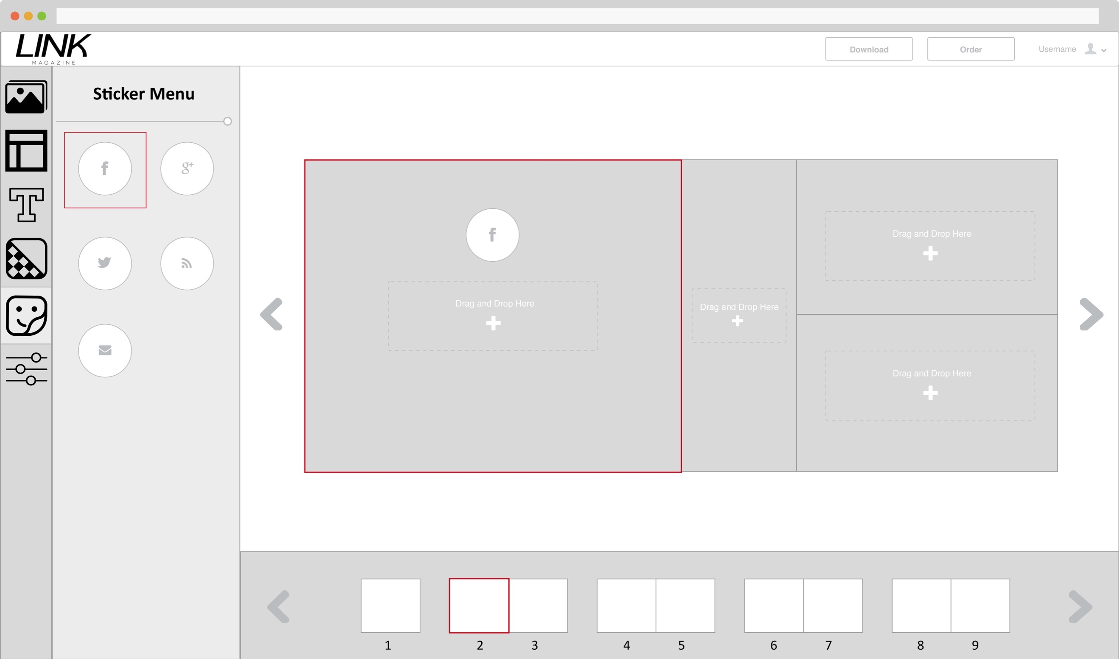

Clicked at the sticker to drop it onto the page.

## **7.6 Scenario 6: Adding Background to the page**

To add background to the current page, first select the background icon on the toolbar menu. Then select the color from the background menu and it will be applied to the page.

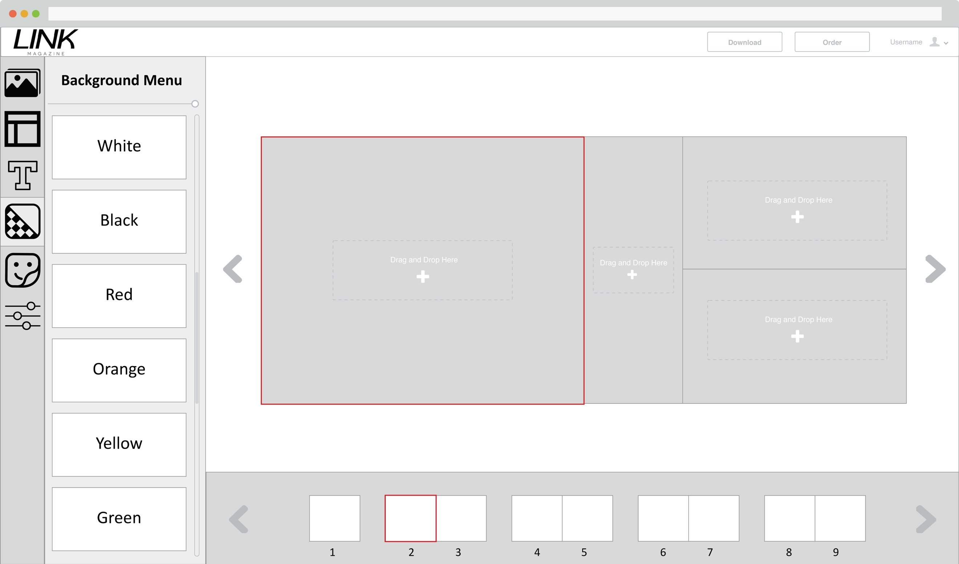

In background menu and selected page 2 that the background will be added.

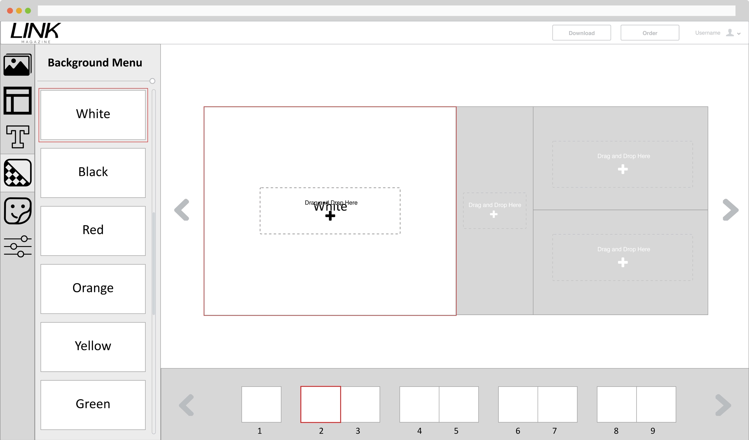

Background white has been selected and added to page 2.

## **7.7 Scenario 7: Applying Filter to the image**

To add filter to the image, first select the filter/adjustment icon on the toolbar menu. Then select the image that needs to apply the filter, and make changes from the filter menu to apply the changes to the image.

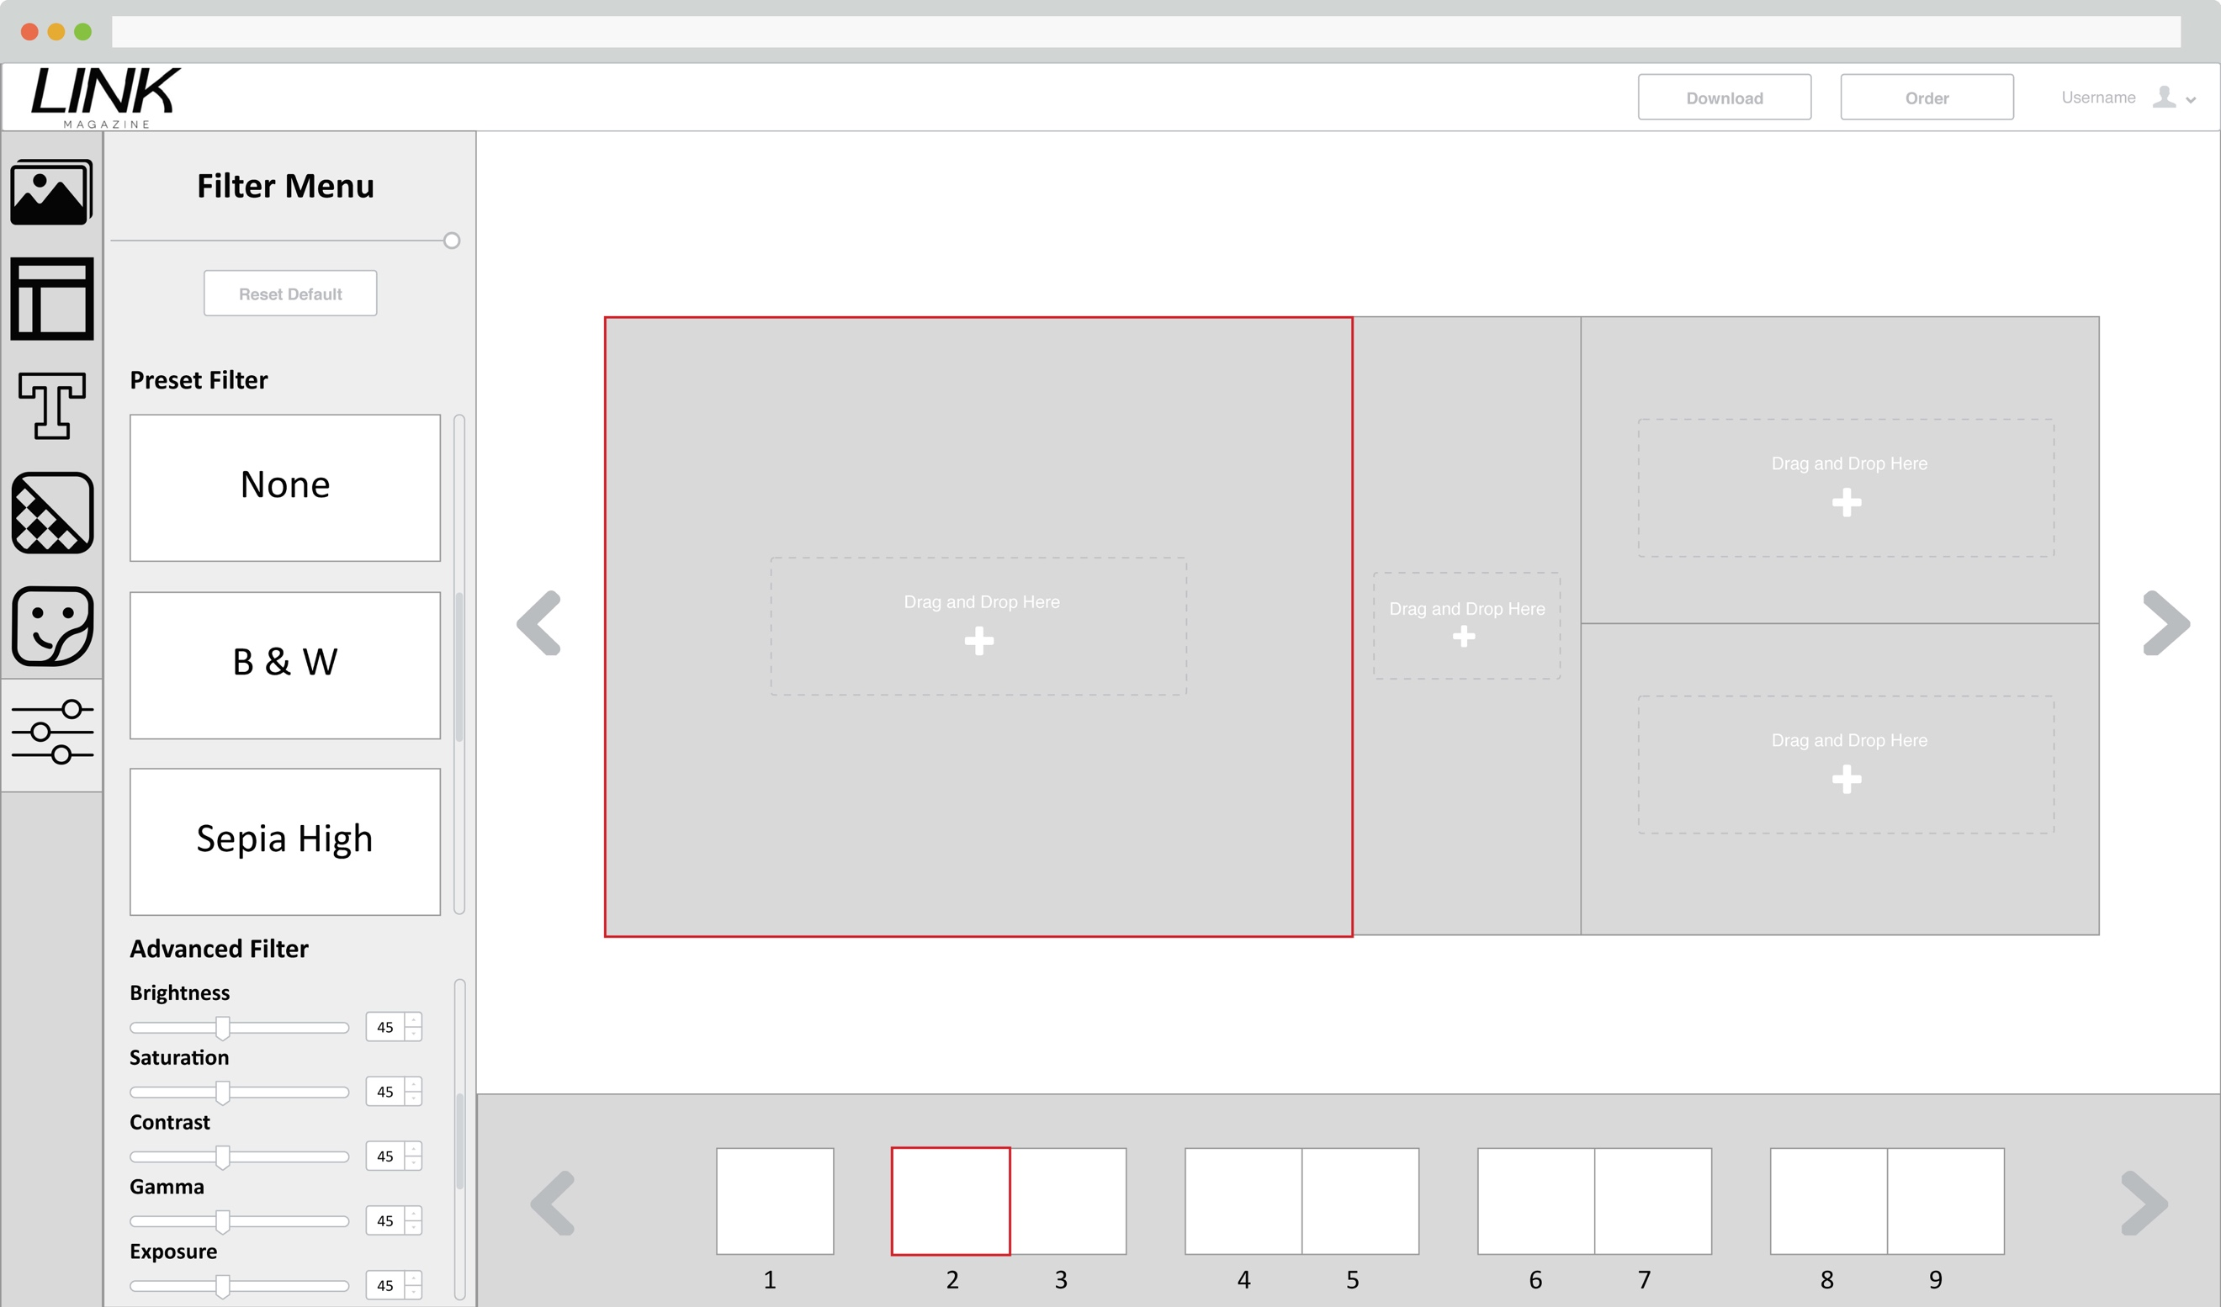

In filter menu and selected page 2 empty image placeholder.

## **7.8 Scenario 8: Downloading the design as print ready pdf**

After the design are finished, click on the download button on the top right to export the design as print ready pdf file.

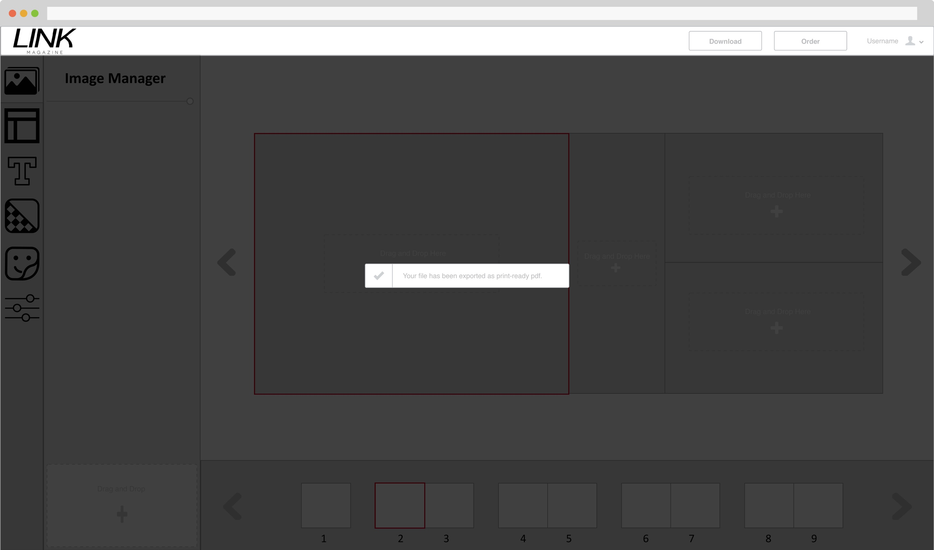

Finished exporting the file and the user is downloading it.

## **7.7 Scenario 9: Send order request to Campus Copy & Print**

To order from the Campus Copy & Print, click on the Order button on the top right and it will pop out an order form to be filled. After submitting the form the user will receive a order confirmation email from Campus Copy & Print.

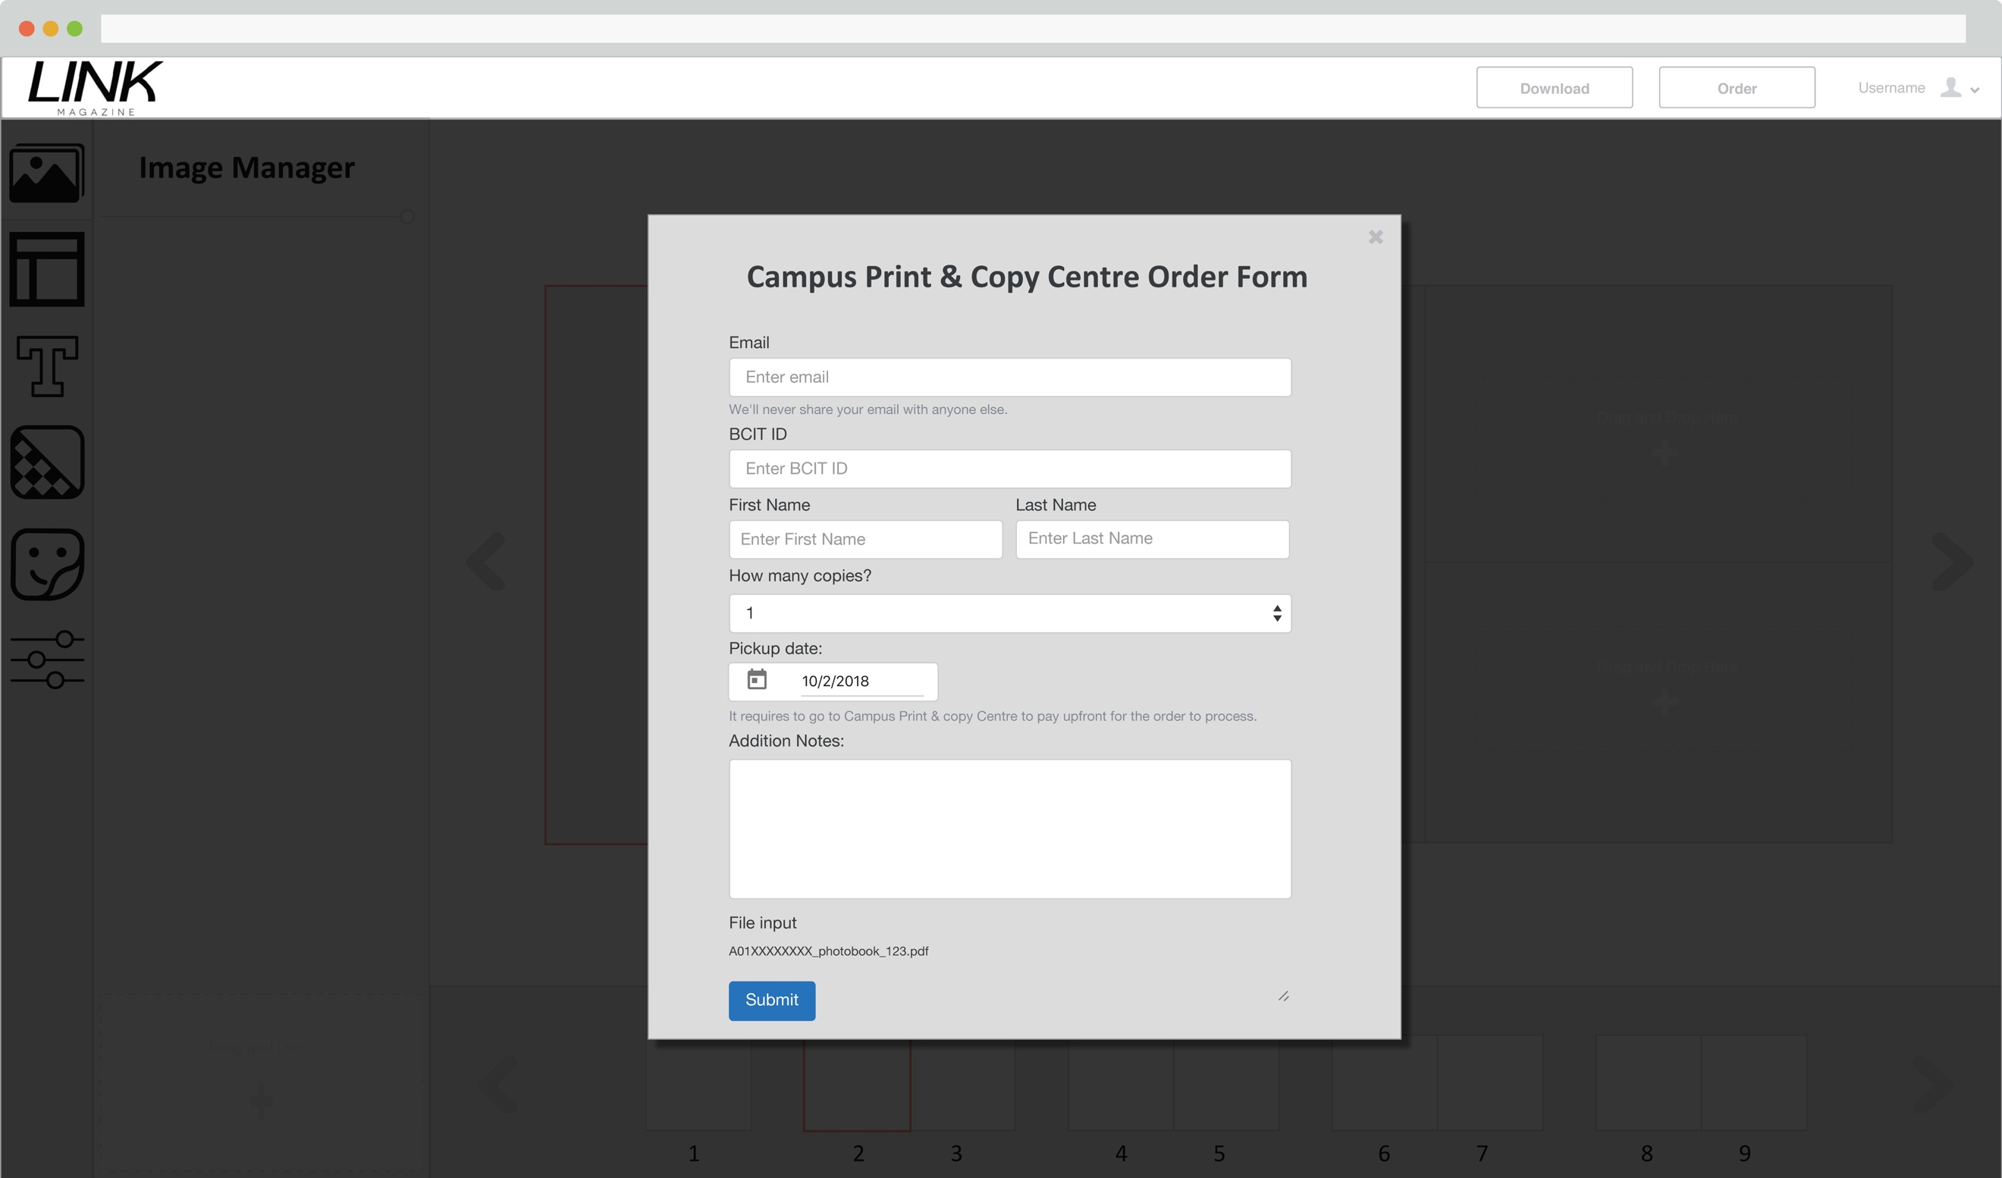

Campus Copy & Print Order form.

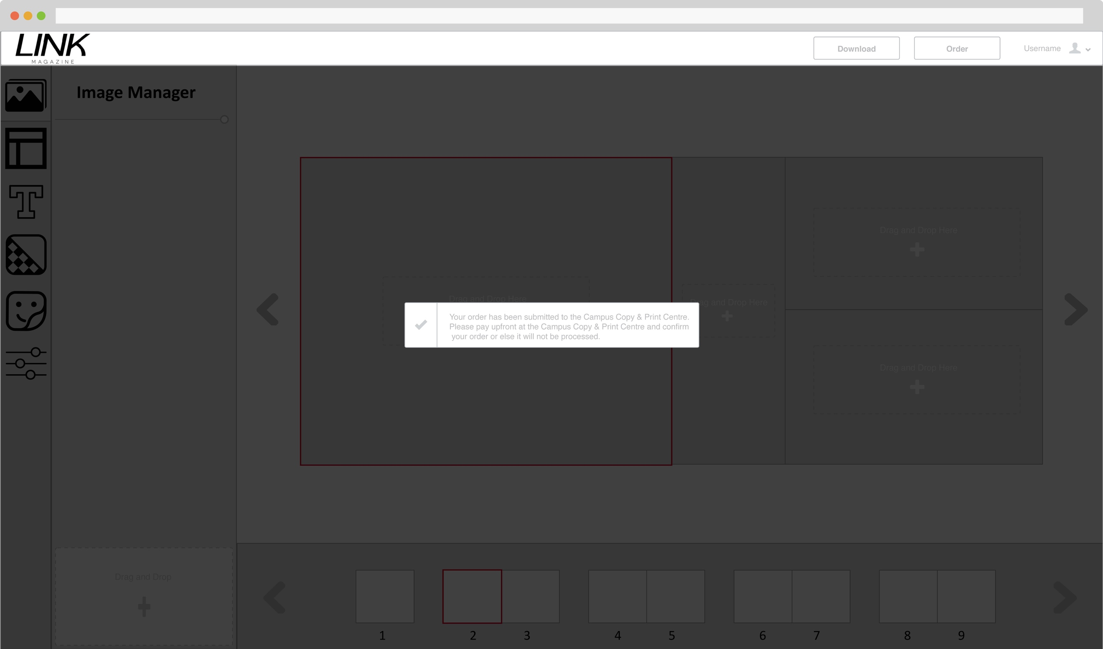

After submitting the order form.